Layout instructions
terminal block labels with
industrial labeling machine Dymo Rhino 6000+

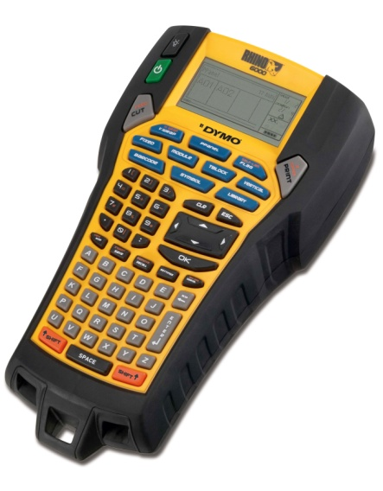

Recommended settings for starters
• Press the Settings key
• Navigate with the Jostick
• Text size / Auto / ok
• CAPS / ON / ok
• Text styles / Bold: on; Source: Narrow
• Green. Lines / On / ok
• Units / mm / ok
• Print Contrast / 20% / ok
After the above steps, press the ESC key to complete

Using the Terminal Blocks Function
• Press the Tblock key
It is set as follows:
• # of blocks (no. Of clamps) typing directly from the numbers or with the help of the Jostick;
• Block width (clamp width) as in # of blocks;
• <ESC> Done press the ESC key to complete the settings.
A preview will appear on the screen. In the first box (first clip) edit the text using the Dymo Rhino 6000+ industrial printer keyboard.

Label serialization for terminal blocks
You can automatically generate labels by serializing them. Start with a pattern and then select the serialization increment.
You can serialize any number or letter by selecting the position to be incremented. For example the number 2 in 123 or the letter B in ABC. When you select 2 of 1 2 3 and the increment is set # = 3, the labels will print 123, 153 and 183.
The letters can also be serialized from A to Z and a to z, and the numbers from 1 to 9. When the serialization reaches Z or 9, a letter or number is added to increase the increment.
Example: increase from Az to Aaa, AZ to BA and A9 to A10.
There are 3 serialization methods: simple, simultaneous and advanced.
Simple serialization creates a series of labels by adding an alphanumeric character to the model.
Example 101, 102, 103, 104, etc.

To use simple serialization:
1. Enter the desired text;
2. Apasti SERIAL. A border will appear around the first character on the label;
3. Use the arrow buttons (joystick) to place the character you want to serialize, press OK;
4. Select the number of increments and press OK. Choose increment in steps up to 10;
5. Select the number of labels you want to print and press OK. You can print a maximum of 99 labels. A new label will appear on the screen for each serialization;
To print multiple copies of the serialized label, press # COPIES (SHIFT + PRINT) and enter the desired number of copies.

Simultaneous serialization
Simultaneous serialization creates a series of labels incrementing 2 different alphanumeric characters at the same time. Example A-101, B-102, C-103, etc.
To use simultaneous serialization:
1. Enter the desired text;
2. Press ADV.SER. (SHIFT + SERIAL);
3. Select Simultaneous and press OK. A border will appear around the character where the cursor was positioned;
4. Select the first character you want to serialize and press OK;
5. Select the second character you want to serialize and press OK;
6. Select how many increments you want to add to the selected characters and press OK. You can choose increments in steps up to 10;
7. Select how many times you want to increment these characters and press OK.
A new label is added to the screen for each new label in the series.

Advanced serialization
Advanced serialization creates a series of labels allowing you to select 2 sequences from the model and serialize them consecutively. Example A-101, A-102, A-103, B-101, B-102, B-103, C-101, C-102, C-103, etc.
To use advanced serialization:
1. Enter the desired text;
2. Press ADV.SER. (SHIFT + SERIAL);
3. Select Advanced and press OK. A border will appear around the character where the cursor was positioned;
4. Select the first character you want to serialize and press OK;
5. Select how many increments you want to add to the selected character and press OK. You can choose increments in steps up to 10;
6. Select how many times you want to increment the selected character and press OK.
7. Repeat steps 4 through 6 for the second character you want to increment.
A new label is added to the screen for each new label in the series.

